**Training Guide**

1. Access the files

Log in info:

Gmail- [ripplegroup2@gmail.com](mailto:ripplegroup2@gmail.com)

Password- rippleGR@up2

Github- [ripplegroup2@gmail.com](mailto:ripplegroup2@gmail.com)

Password- rippleGR@up2

You can log in to github to access the files directly from your browser or download github desktop to edit files from Visual Studio Code or other coding softwares of your choice.

When you open Github Desktop you can log in and open the files by clicking on the repository on the right side.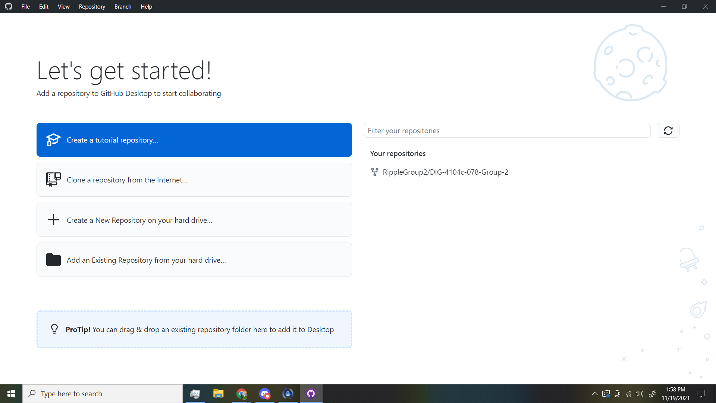

Once here, you can locate the files on your computer by going to the github folder on your computer or clicking the button on the screen to open the file locations.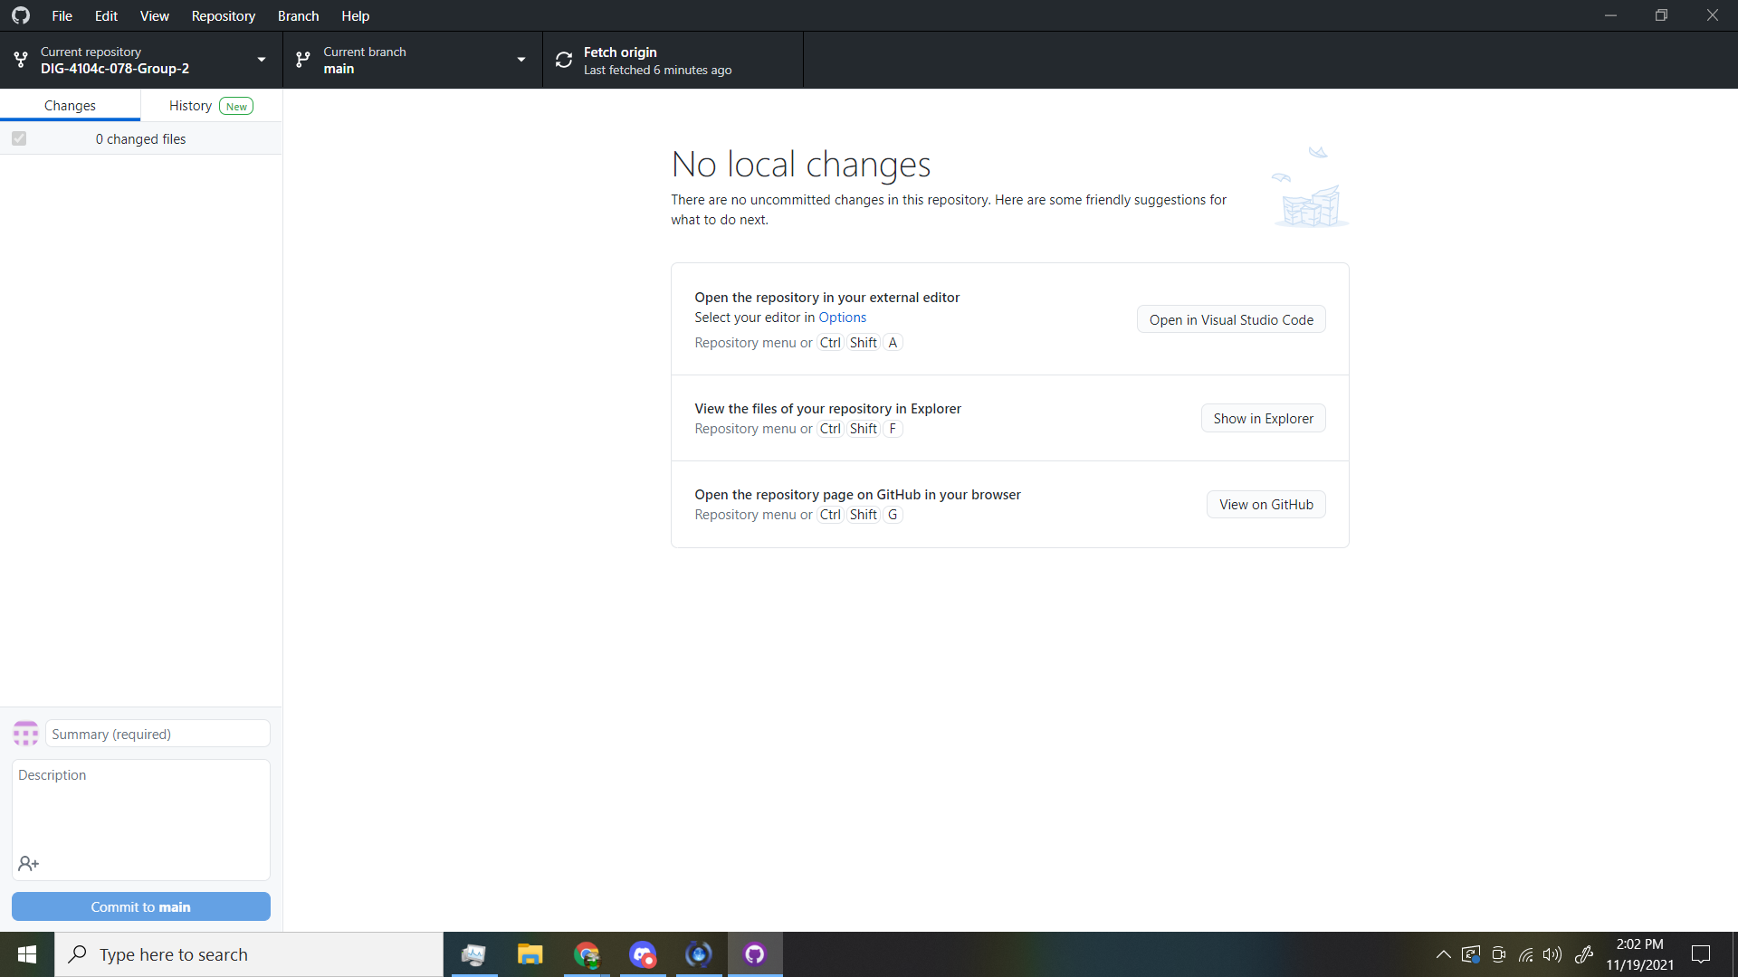

1. Adding and updating files

Once this is open any changes to existing files or additional files you create are added to the github desktop screen.

1. Saving changes

Once you have made and saved all the required changes you can go back to GitHub desktop and commit your changes to main and push to origin.

